PMM09000 – Amortization

TAB – AMORTIZATION LIST

USER INTERFACE
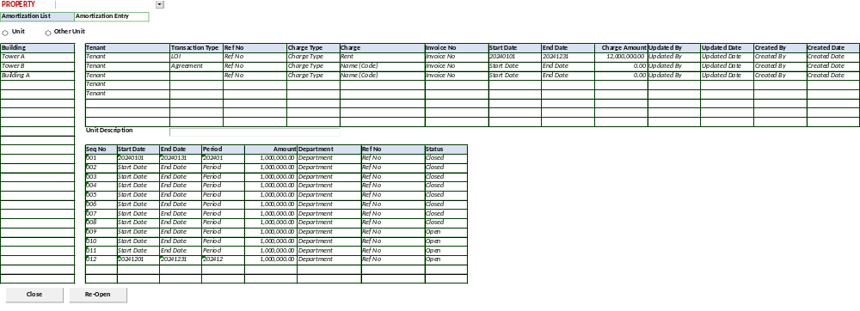

BUTTON DEFINITION
Test
- Close – Untuk Close Amortization.
- Re-Open – Untuk re-open Amortization.

OUTPUT
Test
- None.

ROLES
Test
- Program ini dijalankan oleh operator yang mempunyai hak kewenangan menjalankan Property Management.

INITIAL PROCESS
Test
- Get Property List [PROPERTY_LIST]:
EXEC RSP_GS_GET_PROPERTY_LIST Login CCOMPANY_ID

Set Value : CPROPERTY_NAME
As Parameter: CPROPERTY_ID

- Radio Button Option:
  - [U] – Unit (default)
  - [O] - Other Unit

DISPLAY PROCESS
Test
- Load Building List [BUILDING_LIST]
EXEC RSP_GS_GET_BUILDING_LIST @CCOMPANY_ID, @CPROPERTY_ID, @CUSER_LOGIN_ID

- Building List enabled IF Radio Button = [U] – Unit ELSE set Blank and Disabled
  - "Building"
    - Textbox
    - Display = CBUILDING_NAME
    - Disabled

- Load Amortization List [AMOR_LIST]
EXEC RSP_PM_GET_AMORTIZATION_LIST @CCOMPANY_ID, @CPROPERTY_ID, Unit Option[U/O], @Selected Building Id, @CUSER_LOGIN_ID

  - "Tenant"
    - Textbox
    - Display = CTENANT_NAME
    - Disabled

  - "Transaction Type"
    - Textbox
    - Display = CTRANS_TYPE
    - Disabled

  - "Ref No"
    - Textbox
    - Display = CREF_NO
    - Disabled

  - "Charge Type"
    - Textbox
    - Display = CCHARGES_TYPE_NAME
    - Disabled

  - "Charge"
    - Textbox
    - Display = CCHARGES_NAME
    - Disabled

  - "Invoice No"
    - Textbox
    - Display = CINV_NO
    - Disabled

  - "Start Date"
    - Textbox
    - Display = CSTART_DATE
    - Disabled
  - "End Date"
    - Textbox
    - Display = CEND_DATE
    - Disabled

  - "Charge Amount"
    - Textbox
    - Display = NCHARGES_AMOUNT
    - Disabled

  - "Updated By"
    - Textbox
    - Display = CUPDATE_BY
    - Value = User Login Id
    - Disabled

  - "Updated Date"
    - Textbox
    - Display = DUPDATE_DATE
    - Value = Today Date
    - Disabled

  - "Created By"
    - Textbox
    - Display = CCREATE_BY
    - Value = User Login Id
    - Disabled

  - "Created Date"
    - Textbox
    - Display = DCREATE_DATE
    - Value = Today Date
    - Disabled

- Load Amortization Detail [AMOR_DETAIL]
EXEC RSP_PM_GET_AMORTIZATION_DT @CCOMPANY_ID, @CPROPERTY_ID, Unit Option[U/O], @Selected Building Id, @Selected Trans Type, @Selected Ref No, @CUSER_LOGIN_ID

  - "Unit Description"
    - Textbox
    - Display = CUNIT_DESCRIPTION
    - Disabled

- Load Amortization Schedule List [AMOR_SCHEDULE]
EXEC RSP_PM_GET_AMORTIZATION_SCH @CCOMPANY_ID, @CPROPERTY_ID, Unit Option[U/O], @Selected Building Id, @Selected Trans Type, @Selected Ref No, @CUSER_LOGIN_ID

  - "Seq No"
    - Textbox
    - Display = CSEQ_NO
    - Disabled

  - "Start Date"
    - Textbox
    - Display = CSTART_DATE
    - Disabled

  - "End Date"
    - Textbox
    - Display = CEND_DATE
    - Disabled
  - "Period"
    - Textbox
    - Display = CPERIOD
    - Disabled

  - "Amount"
    - Textbox
    - Display = NAMOUNT
    - Disabled

  - "Department"
    - Textbox
    - Display = CDEPT_NAME
    - Disabled

  - "Ref No"
    - Textbox
    - Display = CREF_NO
    - Disabled

  - "Status"
    - Textbox
    - Display = CSTATUS_DESCR
    - Disabled

- Definisi Button:
  - "Close" – Go to Process
  - “Re-Open” – Go to Process

PROCESS
Test
- Set VAR_SAVE_MODE =
Close = “Close”
Re-Open = “Open”

- On Selected Data running Store Procedure

EXEC RSP_PM_UPDATE_AMORTIZATION_STATUS
Login Company Id
, "Property Id"
, "Unit Option" → [U / O]
, Selected Building Id → Set '' IF Unit Option = [O]
, Selected Trans Type
, Selected Ref No
, VAR_SAVE_MODE = [CLOSE] / [OPEN]
, Login User Id

CANCEL PROCESS
Test
- Tutup program

TAB – AMORTIZATION ENTRY

USER INTERFACE
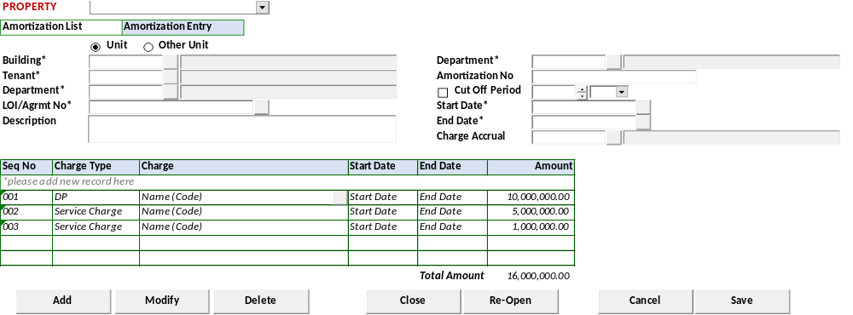

BUTTON DEFINITION
Test
- Button Add
- Button Modify
- Button Delete
- Button Close – Untuk Close Amortization.
- Button Re-Open – Untuk re-open Amortization.

OUTPUT
Test
- None.

ROLES
Test
- Program ini dijalankan oleh operator yang mempunyai hak kewenangan menjalankan Property Management.

INITIAL PROCESS
Test
- Get Property List [PROPERTY_LIST]:
EXEC RSP_GS_GET_PROPERTY_LIST Login CCOMPANY_ID

Set Value : CPROPERTY_NAME
As Parameter: CPROPERTY_ID

- Radio Button Option:
  - [U] – Unit (default)
  - [O] - Other Unit

DISPLAY PROCESS
Test
- Load Amortization Detail [AMOR_DETAIL]
EXEC RSP_PM_GET_AMORTIZATION_DT @CCOMPANY_ID, @CPROPERTY_ID, Unit Option[U/O], @Selected Building Id, @Selected Trans Type, @Selected Ref No, @CUSER_LOGIN_ID

  - "Building"*
    - Textbox
    - Mandatory
    - Enabled IF Radio Button Option: [U] – Unit ELSE Set Disabled
    - Display = CBUILDING_NAME
    - Field = CBUILDING_CODE
    - Value = Lookup GSL02200 – Building Lookup
With Parameter:
      - Login Company Id
      - Login Property Id
      - User Login Id

  - "Tenant"*
    - Textbox
    - Mandatory
    - Display = CTENANT_NAME
    - Field = CTENANT_ID
    - Value = Lookup PML00600 – Tenant Lookup
With Parameter:
      - Login Company Id
      - Login Property Id
      - Customer Type = [01] - Tenant
      - User Login Id

  - "Department"*
    - Textbox
    - Mandatory
    - Display = CDEPT_NAME
    - Field = CDEPT_CODE
    - Value = Lookup GSL00710 – Department Property Lookup
With Parameter:
      - Login Company Id
      - Login Property Id
      - User Login Id

  - "LOI/Agrmt No"*
    - Textbox
    - Mandatory
    - Display = CREF_NO
    - Value = Lookup PML01300 – LOI/AGREEMENT LOOKUP
With Parameter:
      - Login Company Id
      - Login Property Id
      - Selected Dept Code
      - Login Language Id
      - Selected Tenant Id

    - Run lookup automatically, IF there’s only 1 transaction then set as default

  - "Description"*
    - Textbox
    - Display = CDESCRIPTION

  - "Department"* (transaction)
    - Textbox
    - Mandatory
    - Display = CTRANS_DEPT_NAME
    - Field = CTRANS_DEPT_CODE
    - Value = Lookup GSL00710 – Department Property Lookup
With Parameter:
      - Login Company Id
      - Login Property Id
      - User Login Id

  - "Amortization No"*
    - Textbox
    - Mandatory
    - Display = CAMORTIZATION_NO
    - Default Value = CTRANS_DEPT_CODE + _ + CREF_NO

  - "Cut Off Period" flag
    - Checkbox
    - Display = LCUT_OFF_PRD
    - Value = [1] Checked / [0] Unchecked
    - Default Value = [0] Unchecked

  - "Cut Off Period"
    - Year
      - Numeric Spinner
      - Display = CPERIOD_YEAR
      - Value = EXEC RSP_GS_GET_TAX_NEXT_PERIOD [Login CCOMPANY_ID], ‘S’

    - Month
      - Combobox
      - Display = CPERIOD_MONTH
      - Value =
EXEC RSP_TX_GET_PERIOD_DT_LIST [Login CCOMPANY_ID], [Selected Year], ‘S’

  - "Start Date"*
    - Datetime Picker
    - Mandatory IF "Cut Off Period" flag = 1
    - Display = CSTART_DATE
    - Default Value = "Cut Off Period" + 01

  - "End Date"*
    - Datetime Picker
    - Mandatory IF "Cut Off Period" flag = 1
    - Display = CEND_DATE
    - Default Value = "Cut Off Period" + 01

  - "Charge Accrual"
    - Lookup
    - Display = CCHARGES_ID, CCHARGES_NAME
    - Value = Lookup PML00200 – Unit Charges
With Parameter:
Login Company Id
Selected Property Id
Selected Charges Type
User Login Id
‘’
‘’
‘’
LACCRUAL = 1

- Load Amortization Schedule List [AMOR_SCHEDULE]
EXEC RSP_PM_GET_AMORTIZATION_SCH @CCOMPANY_ID, @CPROPERTY_ID, Unit Option[U/O], @Selected Building Id, @Selected Trans Type, @Selected Ref No, @CUSER_LOGIN_ID

  - "Seq No"
    - Textbox
    - Display = CSEQ_NO
    - Disabled
    - Auto Generated, Last Seq + 1
    - Format = 000

  - "Charge Type"
    - Combobox
    - Display = CCHARGES_TYPE_ID, CCHARGES_TYPE_NAME
    - Value = SELECT * FROM RFT_GET_GSB_CODE_INFO ('SIAPP', 'Login Company Id', '_BS_UNIT_CHARGES_TYPE', '', 'Login Language Id')

  - "Charges"
    - Lookup
    - Display = CCHARGES_ID, CCHARGES_NAME
    - Value = Lookup PML00200 – Unit Charges
With Parameter:
Login Company Id
Selected Property Id
Selected Charges Type
User Login Id
‘’
‘’
‘’
LACCRUAL = 0

  - "Start Date"
    - Datetime Picker
    - Display = CSTART_DATE
    - Enabled IF "Cut Off Period" flag = 0

  - "End Date"
    - Datetime Picker
    - Display = CEND_DATE
    - Enabled IF "Cut Off Period" flag = 0

  - "Amount"
    - Textbox
    - Display = NAMOUNT
    - Numeric Input Only

  - "Total Amount"
    - Textbox
    - Display = NTOTAL_AMOUNT
    - Value = SUM(NAMOUNT)

- Proses
  - "Add New" → Go to ADD NEW PROCESS
  - "Modify"→ Go to EDIT PROCESS
  - "Delete"→ Go to DELETE PROCESS
  - "Close" → Go to Process
  - “Re-Open” → Go to Process

ADD NEW PROCESS
Test
- Set VAR_SAVE_MODE = NEW
- Enabled fields: All Field
- Set focus to column: IF [U] Unit "Building", ELSE "Tenant"

- Proses
        - “Save” → Go to SAVE & VALIDATION PROCESS
        - “Cancel”→ Go to DISPLAY PROCESS

MODIFY PROCESS
Test
- Set VAR_SAVE_MODE = EDIT
- Enabled fields: All Field
- Disabled fields: "Department" transaction, "Amortization No"
- Set focus to column: "Cut Off Period"

- Proses
        - “Save” → Go to SAVE & VALIDATION PROCESS
        - “Cancel”→ Go to DISPLAY PROCESS

DELETE PROCESS
Test
- Set VAR_SAVE_MODE = DELETE

- DELETE PROCESS
CREATE TABLE #AMOR_SCH(CSEQ_NO VARCHAR(3)
, CCHARGES_TYPE_ID VARCHAR(2)
, CCHARGES_ID VARCHAR(20)
, CSTART_DATE VARCHAR(8)
, CEND_DATE VARCHAR(8)
, NAMOUNT NUMERIC(18,2)
)

EXEC RSP_PM_MAINTAIN_AMORTIZATION
"Login Company Id"
, "Selected Property Id"
, Selected Unit Option → [U] Unit / [O] Other Unit
, "Building"*
, "Tenant"*
, "Department"*
, "LOI/Agrmt No"*
, "Description"*
, "Department"*(transaction)
, "Amortization No"*
, "Cut Off Period" flag
, "Cut Off Period"
, "Start Date"*
, "End Date"*
, "Charge Accrual"
, CACTION [DELETE]
, Login User Id

SAVE & VALIDATION PROCESS
Test
- Save Amortization

CREATE TABLE #AMOR_SCH(CSEQ_NO VARCHAR(3)
, CCHARGES_TYPE_ID VARCHAR(2)
, CCHARGES_ID VARCHAR(20)
, CSTART_DATE VARCHAR(8)
, CEND_DATE VARCHAR(8)
, NAMOUNT NUMERIC(18,2)
)

EXEC RSP_PM_MAINTAIN_AMORTIZATION
"Login Company Id"
, "Selected Property Id"
, Selected Unit Option → [U] Unit / [O] Other Unit
, "Building"*
, "Tenant"*
, "Department"*
, "LOI/Agrmt No"*
, "Description"*
, "Department"*(transaction)
, "Amortization No"*
, "Cut Off Period" flag
, "Cut Off Period"
, "Start Date"*
, "End Date"*
, "Charge Accrual"
, CACTION [ADD / EDIT]
, Login User Id

- Go to DISPLAY PROCESS

PROCESS
Test
- Set VAR_SAVE_MODE =
Close = “Close”
Re-Open = “Open”

- On Selected Data running Store Procedure

EXEC RSP_PM_UPDATE_AMORTIZATION_STATUS
Login Company Id
, "Property Id"
, "Unit Option" → [U / O]
, Selected Building Id → Set '' IF Unit Option = [O]
, Selected Trans Type
, Selected Ref No
, VAR_SAVE_MODE = [CLOSE] / [OPEN]
, Login User Id

CANCEL PROCESS
Test
- Tutup program dan kembali ke Amortization Entry

CR LIST
CR No. | Description | Notes

